

**Year 12 Examination, 2019**

**Question/Answer Booklet**

**MATHEMATICS SPECIALIST**

**Section One: Calculator-free**

Student Name/Number: ______________________________________________

Teacher Name: ______________________________________________

**Time allowed for this section**

Reading time before commencing work: five minutes

Working time for this section: fifty minutes

**Materials required/recommended for this section**

**To be provided by the supervisor:** This Question/Answer Booklet

Formula Sheet

**To be provided by the candidate:**

Standard items: pens (blue/black preferred), pencils (including coloured), sharpener,

correction fluid/tape, eraser, ruler, highlighters

Special items: nil

**Important note to candidates**

No other items may be taken into the examination room. It is **your** responsibility to ensure that you do not have any unauthorised notes or other items of a non-personal nature in the examination room. If you have any unauthorised material with you, hand it to the supervisor **before** reading any further.

**Structure of this paper**

|  |  |  |  |  |  |
| --- | --- | --- | --- | --- | --- |
| Section | Number of questions available | Number of questions to be answered | Working time (minutes) | Marks available | Percentage of exam |
| Section One: Calculator-free | 8 | 8 | 50 | 54 | 35 |
| Section Two: Calculator-assumed | 13 | 13 | 100 | 100 | 65 |
|  | | | | | 100 |

**Instructions to candidates**

1. The rules for the conduct of School exams are detailed in the *_______________________________________School/College assessment policy*. Sitting this examination implies that you agree to abide by these rules.
2. Write your answers in this Question/Answer booklet preferably using a blue/black pen. Do not use erasable or gel pens.
3. You must be careful to confine your answer to the specific question asked and to follow any instructions that are specified to a particular question.
4. Show all your working clearly. Your working should be in sufficient detail to allow your answers to be checked readily and for marks to be awarded for reasoning. Incorrect answers given without supporting reasoning cannot be allocated any marks. For any question or part question worth more than two marks, valid working or justification is required to receive full marks. If you repeat any question, ensure that you cancel the answer you do not wish to have marked.
5. It is recommended that you do not use pencil, except in diagrams.
6. Supplementary pages for planning/continuing your answers to questions are provided at the end of this Question/Answer booklet. If you use these pages to continue an answer, indicate at the original answer where the answer is continued, i.e. give the page number.
7. The Formula sheet is not to be handed in with your Question/Answer booklet.

**Section One: Calculator-free 35% (54 Marks)**

This section has **eight (8)** questions. Answer **all** questions. Write your answers in the spaces provided.

Supplementary pages for planning/continuing your answers to questions are provided at the end of this Question/Answer booklet. If you use these pages to continue an answer, indicate at the original answer where the answer is continued, i.e. give the page number.

Working time: 50 minutes

**Question 1 (4 marks)**

A slope field is given by the equation .

Determine the equation of the curve that passes through the point .

**Question 2 (12 marks)**

1. Evaluate . (3 marks) 
2. Use the trigonometrical identity  to evaluate

 . (3 marks)

1. Use the substitution  to determine  . (3 marks)

1. Use partial fractions to determine

 . (3 marks)

**Question 3 (6 marks)**

Consider the following system of linear equations:

$$2x+y+z=1$$

$$5x+3y-2z=2$$

$$9x+5y+az=6$$

where $a$ is a real number.

1. Solve the system of equations when $a=2.$ (4 marks)
2. Determine the value of $a$ for which the system of equations has no solution. (2 marks)

**Question 4 (7 marks)**

1. (i) Verify that . (1 mark)

(ii) Hence, or otherwise, solve the equation . (2 marks)

1. Express the complex number  in polar form. (2 marks)
2. Describe the geometrical effect in the Argand diagram of multiplying a complex number by  as given in (b) above. (2 marks)

**Question 5 (5 marks)**

The equation of the plane P is

$$2x+y-2z=18$$

1. Determine a unit vector that is a normal to P. (2 marks)
2. Determine the coordinates of the point on P that is closest to the origin. (3 marks)

**Question 6 (6 marks)**

1. On the axes below, sketch the graph of , showing clearly the *x* and *y* intercepts and asymptotes. (4 marks)

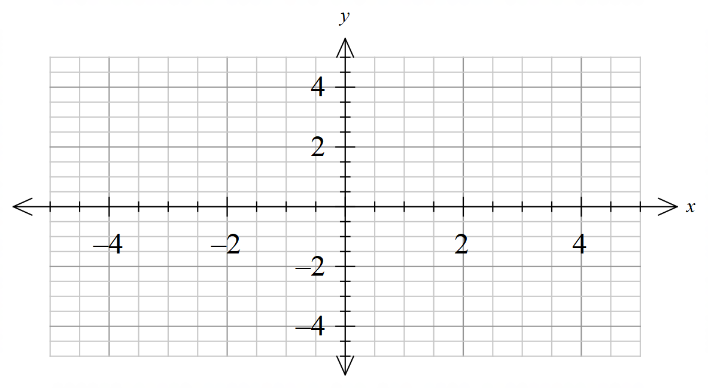

1. You are given that the equation of the tangent to the curve at (0,1) is .

Use your sketch to determine the values of *k* for which  has two non-negative real roots. (2 marks)

**Question 7 (8 marks)**

The diagram below shows a fixed point, *Q* on the *y-*axis with *OQ* = 5 cm.

A variable point *P* can move along the positive *x-*axis.

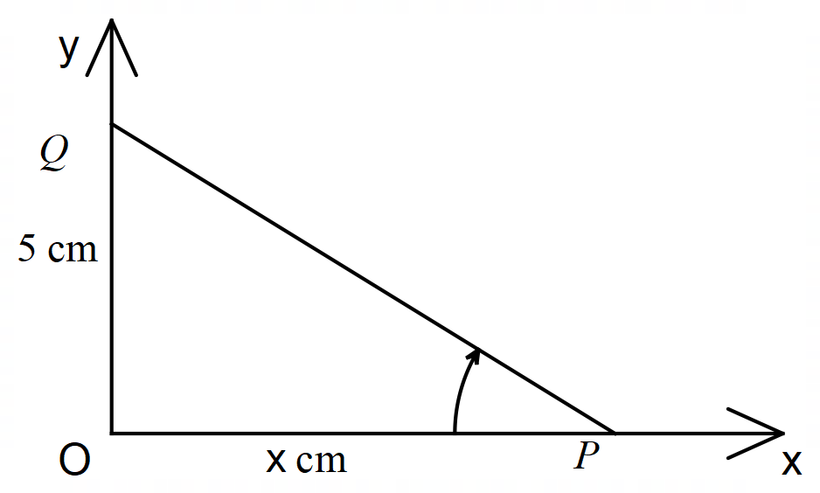

Let  radians.

(a) Derive an expression for *x* in terms of . (2 marks)

(b) Determine  in its simplest form. (2 marks)

1. If the point *P* is moving towards *O* with a constant speed of 3 cm/sec, determine the rate of change of  with respect to time when *x =* 5. (4 marks)

**Question 8 (6 marks)**

Random samples are taken from a large population of real numbers, and from these samples confidence intervals for the population mean $μ$ are constructed.

Which of the following statements are true and which are not? Give brief justifications for your assertions.

1. Each $90\%$ confidence interval will contain $90\%$ of the underlying population. (2 marks)
2. If there are twenty $95\%$ confidence intervals, exactly nineteen of them will contain the mean $μ.$ (2 marks)
3. If the width of one confidence interval is half the width of another which has the same level of confidence, then its sample size is four times as large. (2 marks)

**END OF QUESTIONS**

**Additional working space**

Question number: __________________

**Additional working space**

Question number: __________________

**Acknowledgements**

© MAWA, 2019

This examination is Copyright but may be freely used within the school that purchases this licence.

* The items that are contained in this examination are to be used solely in the school for which they are purchased.
* They are not to be shared in any manner with a school which has not purchased their own licence.
* The items and the solutions/marking keys are to be kept confidentially and not copied or made available to anyone who is not a teacher at the school. Teachers may give feedback to students in the form of showing them how the work is marked but students are not to retain a copy of the paper or the marking guide until the agreed release date stipulated in the purchasing agreement/licence.

*Published by The Mathematical Association of WA*

*12 Cobbler Place, MIRRABOOKA 6164.*